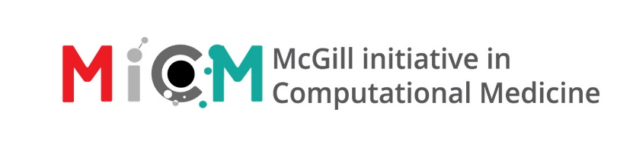
Intro to Python (Fall 2025)
Workshop Lead: Benjamin Rudski
Facilitator: N/A
Registration link: https://involvement.mcgill.ca/event/288033
Approximate duration: 4 hours
Prerequisites:
- Basic computer science knowledge of data types and control structures.
- No prior programming experience is required, but knowing another language may help.
- To be able to participate in the exercises, participants must either:
  - Have a local installation of Python and Jupyter notebooks. Microsoft Visual Studio Code with the Python extension installed can also be used to run the Notebook.
  - Have a Google Account (to run in-browser as a Colab notebook)
Summary: (2-3 sentences summarizing the workshop)
In this 4-hour workshop, participants will be introduced to the basics of programming in Python. Students will journey from the beginnings of creating variables and performing simple mathematical operations to writing code that can perform fundamental tasks and wrapping this code into functions. Participants will learn how to write the important building blocks that make up complex programs.

Learning Objectives: (List 3-5 learning objectives participants will learn upon completion of this workshop)
- Store data in variables and collections.
- Perform basic operations on these data.
- Use control flow and loops to write powerful code.
- Define functions to create repeatable units of behaviour.
Content:
- Module 1 – Python Basics (1 hour)
  - Hello, World!
    - Into the Python-verse!
    - Python Tools
  - Variables
    - Variable names
    - Variable Assignment
  - Numbers and Comparisons
    - Mathematical operations
    - Booleans and logical operators
  - Intro to strings
    - String slicing and indexing
    - String formatting
    - String methods
  - Exercises: Temperature conversion and DNA GC content
- Module 2 – Collections (1 hour)
  - Lists and List Methods
    - Length of a list
    - List slicing
    - Adding elements
    - Removing elements
    - Other useful list methods
  - Tuples
    - Tuple unpacking
  - Dictionaries
    - Retrieving elements
    - Adding and modifying elements
    - Removing elements
  - Exercises: Working with collections
- Module 3 - Intro to Control Flow and Loops (40 minutes)
  - Control Flow: the if statement
  - Loops
    - while loops
    - Iteration with for loops
    - Interrupting loops
  - Exercises: Working with Strings and Collections for DNA and Protein Processing
- Module 4 – Introduction to Functions (30 minutes)
  - Function Overview
    - What is a function?
    - Calling built-in functions
  - Writing Custom Functions
    - Function definition
    - Function parameters
    - Function Return values
  - Documenting Functions
    - Defining function docstrings
  - To script, or not to script?
  - Exercises: Writing functions for biological sequences
- Module 5 – Where to go from here (10 minutes)
  - What to learn next? How?
  - How to get help and how not to get help
  - Glimpse of other cool programming topics

